

Packet Tracer - Compare Layer 2 and Layer 3 Devices

Nombres: Brayan Ortiz Cundar, Luis Pérez Señalin y Jossué

Rivadeneira Ordóñez

# Objectives

**Part 1: Compare Layer 2 and Layer 3 Switches Part 2: Compare a Layer 3 Switch and a Router**

# Background / Scenario

In this activity, you will use various commands to examine three different switching topologies and compare the similarities and differences between the 2960 and 3650 switches. You will also compare the routing table of a 4321 router with that of a 3650 switch.

**Note:** Search the internet for more details about the *WS-C3650-24PS-L Layer 3 switch* and the *ISR 4321/K9*

router.

# Instructions

**Part 1: Compare Layer 2 and Layer 3 Switches**

## Step 1: Explore the Physical Workspace.

1. In the Physical Workspace, click the **Home City** image. Click the **Corporate Office** image. Click the **Main Wiring Closet** image.

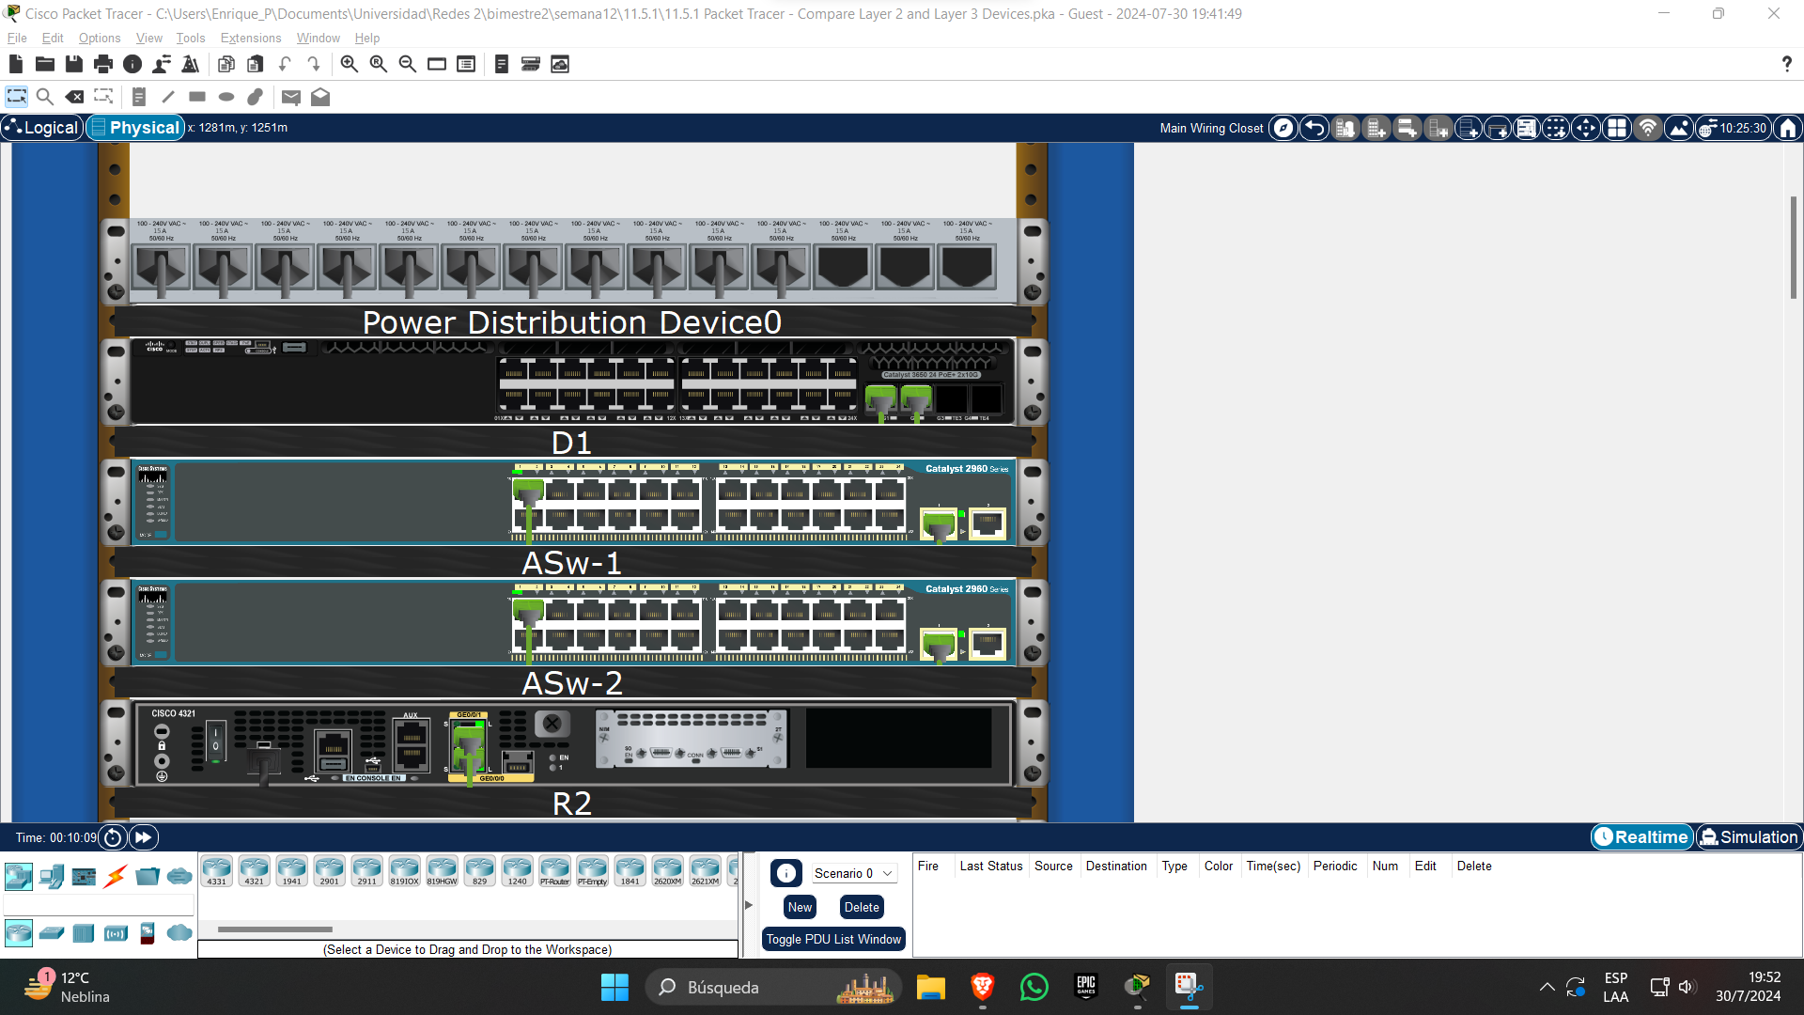

1. In the Rack, locate the devices **D1** and **ASw-1**. Examine the physical aspects of **D1** and **ASw-1**. If you need to examine the devices more closely, click the device and select the Physical tab.

Each individual switch has how many physical switchports?

**R:** D1: 24 static ports and 4 modular ports – Asw-1: 26 static ports.

How many Fast Ethernet and Gigabit Ethernet switchports does each switch have?

**R:**

D1: 28 GigabitEthernet ports, (2 modular ports are not connected.

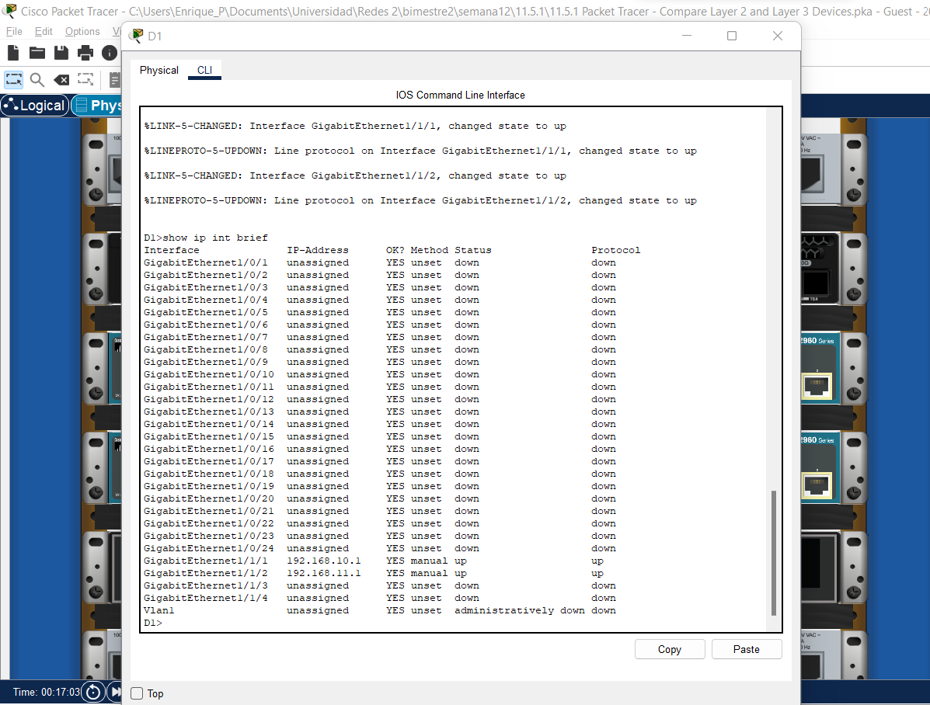

Asw-1: 24 FastEthernet ports and 2 GigabitEthernet ports

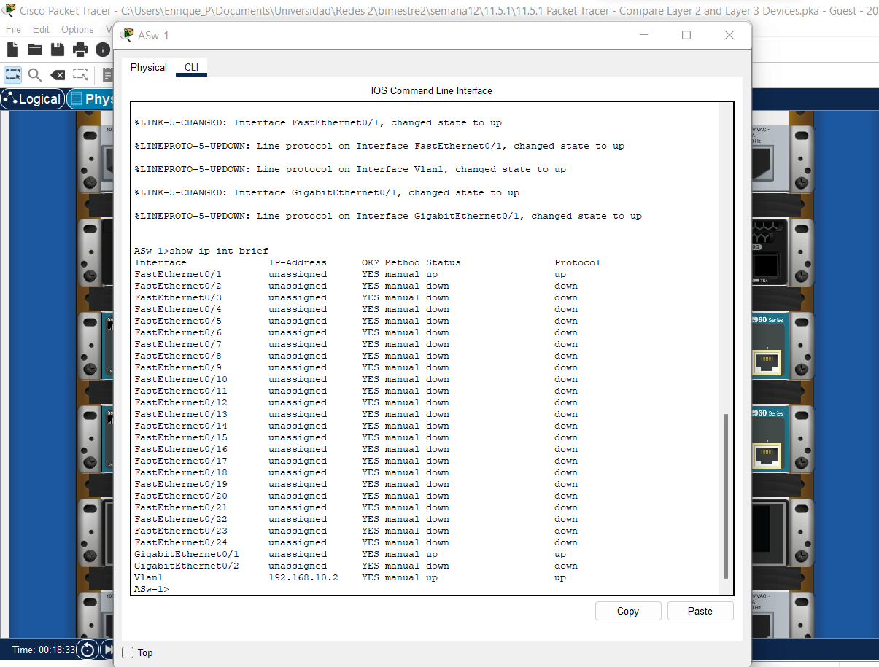

List the transmission speed of the Fast Ethernet and Gigabit Ethernet switchports on each switch.

**R:** The fastEthener have 100 Mb/s and the GigabitEthernet have 1000 Mb/s on both switches.

Are either of the two switches modular in design?

**R:** Only the D1(3650) switch have a modular design.

## Step 2: In the CLI tab

1. The switchports of a 3650 switch can be configured as Layer 3 interfaces by entering the **no switchport** command in interface configuration mode. This allows technicians to assign an IP address and subnet mask to the switchport in the same way that they are configured on a router interface.

What is the difference between a Layer 2 switch and a Layer 3 switch?.

**R:** The Layer 2 switches use the MAC address to forward the data and the Layer 3 switches can be configured the interfaces to use ip directions. Layer 3 switches can use routing protocols.

What is the difference between a switch’s physical interface and the VLAN interface?

**R:** The physical interface allows connect physical the networks terminals. VLAN allow assign to the Switch an ip address to configured the switch through other devices like PC, laptops, routers, etc.

At which layers do 2960 and 3650 switches operate?

**R:** The 2960 switch operate in the layer 2 and the 3650 switch operate in the layer 2 and 3.

1. Interfaz de usuario gráfica, Aplicación

   Descripción generada automáticamenteInterfaz de usuario gráfica, Texto, Aplicación, Word

   Descripción generada automáticamenteNavigate to the CLI tab for both devices. Issue the **show run** command to examine the configurations of the **D1** and **ASw-1** switches.

Do you notice any differences between them?

**R:** The D1 switch have the ip routing configuration to allow the protocols routing, the D1 assign ip address to the interfaces, the Asw-1 use a Vlan1 to assign the ip address to the configuration.

1. Interfaz de usuario gráfica, Texto, Aplicación

   Descripción generada automáticamenteTry to display the routing table on D1 and ASw-1 using the **show ip route** command.

Why do you think the command does not work on **ASw-1** but works on **D1**?

**R:** The ASw-1 can’t route protocols, so ASw-1 can’t have a routing table but D1 can routing protocols and have a routing table.

# Part 2: Compare a Layer 3 Switch and a Router

In the past, switches and routers have been separate and distinct devices. The term switch was set aside for hardware devices that function at Layer 2. Routers, on the other hand, are devices that make forwarding decisions based on Layer 3 information. They use routing protocols to share routing information and to communicate with other routers. Layer 3 switches, such as the 3650, can be configured to forward Layer 3 packets. Entering the **ip routing** command in global configuration mode allows Layer 3 switches to be configured with routing protocols, which gives them some of the capabilities of a router. Although similar in some ways, Layer 3 switches are different from routers in many other aspects.

## Step 1: Compare D1 and R1

1. Open the Physical tab on D1 and R1.

Do you notice any similarities between the two? Do you notice any differences between the two?

**R:** The share a console port, usb port and the modular feature, The R1 have console ports, the D1 have more Gigabit ports.

1. In the CLI tab, issue the **show run** command and examine the configurations of R1 and D1.

What differences do you see between the two?

**R:** The D1 switch needs to configurate the Gigabit ports with “no switchport” to assign ip address and the R1 have Serial ports.

Which command allows configuration of D1 with an IP address on one of its physical interfaces?

**R:** No switch port.

1. Use the **show ip route** command on both devices.

Do you see any similarities or differences between the two tables?

**R:** The R1 have the Codes L-Local that is the physical port of the router.

## Step 2: Compare R2 and D2

1. Now, analyze the routing table of R2 and D2. Click both devices in the Rack. In the CLI tab, issue the

**show ip route** command.

What is present now that was not present in the configuration of R1 and D1?

**R:** Both have the code O – OSPF

Which network is in the routing table of D2 that was learned from R2?

**R:** The network 1.1.1.0 is learned from R2 in D2.

1. Click the **Back Level** icon (Alt + Left) to leave the Main Wiring Closet. Verify that each topology has full connectivity by completing the following tests:

Ping from **PC1** to **PC2**

Ping from **PC3** to **PC4**

Ping from **PC5** to **PC6** and **PC7**

In all three examples, each PC is on a different network.

**R:** Yes

**Note**: You may need to move the PCs to see them.

Which device is used to provide communication between networks?

**R:** The network between PC1 and PC2 are a Multilabel switch, the network between PC3 and PC4 are a Router and the network between PC5 to PC6 and PC7 are a Multilabel switch and a router.

Why were we able to ping across networks without there being a router?

**R:** The Multiplabel Switch have the routing configuration and the “no switch port”.

**Bonus question:** We say that routers are Layer 3 devices and conventional (non-Layer 3) switches are Layer 2 devices. However, we can assign an IP address to a management (SVI) interface of a Layer 2 switch. How is this possible if switches are Layer 2 devices?

**R:** The Label 2 switch only can configurate the ip address on a SVI to configurate the switch from another devices.